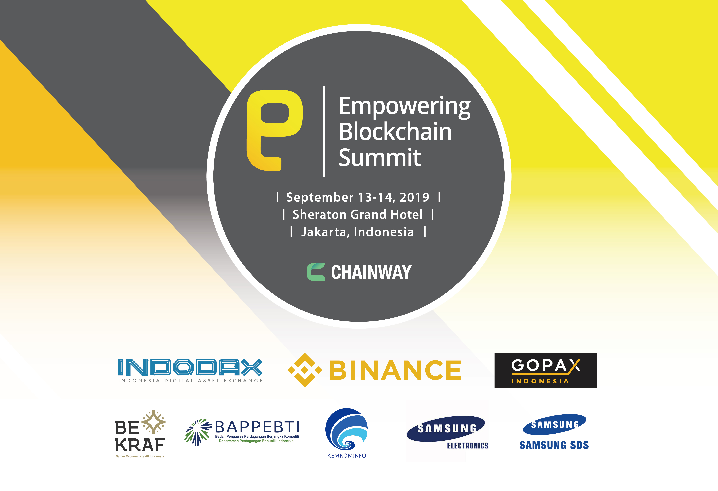
Empowering Blockchain Summit, a platform to find solutions and share insights on the better way of applying the blockchain technology into the overall industry in Indonesia with other Southeast Asian countries, will be held in Jakarta, Indonesia on September 13 and 14.

Powered by Chainway, an Indonesia-based blockchain business platform, the inaugural summit will bring major companies’ leaders, founders and developers together to build momentum and to engage in a discussion about the future of blockchain industry.

Chainway is a newly founded blockchain enterprise in Jakarta for linking global blockchain businesses with Indonesian blockchain industries and providing business solutions.

The summit will feature high-profile figures in global blockchain and crypto asset world. Some of the biggest partners are BINANCE, Samsung SDS, INDODAX, Samsung Electronics Indonesia, QCP Capital, SolidBlock and Gopax Indonesia.

On the first day, the most influential global players in blockchain and crypto asset industries will share the outlook of the blockchain industry and the practical ways of applying it to the public and private sectors. There will also be minister-level government officials to speak about the near future industry with blockchain technology and the prospects of the regulation framework.

The second day will focus on what is happening in the blockchain market and the survival strategies. Furthermore, BINANCE Super Meetup will take place for discussing and sharing on trading, blockchain technology and other BINANCE features with its distinguished speakers.

The summit will be held at Sheraton Grand Jakarta Gandaria City Hotel. The summit is currently receiving registrations for tickets. The standard tickets cost $150 while early bird tickets cost $100. The deadline for early bird registration is September 8.

Visit empoweringblockchainsummit.com for more information.

